**CE101 Engineering Drawing July- Nov 2019**

**Indian Institute of Technology Guwahati**

**Lab Sheet-9 Development of Surfaces Monday Morning**

**Full Marks: 100 Date:.21.10.2019**

1. Draw the development of the complete surface of a pentagonal prism of base 30 mm and height 70 mm along with its FV and TV. (15 Marks)
2. Draw the development of the lateral surface of the cylinder of 45 mm base diameter as shown in figure below. (35 Marks)

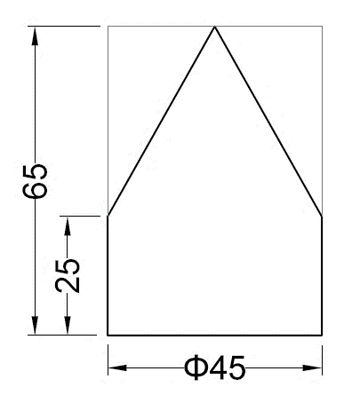

1. A pentagonal pyramid of base side 30 mm and length of axis 60 mm is kept on the ground on its base. A thread is wound around the pyramid in such a way that it starts from a corner of the base and comes back to the same corner after completing one revolution by the shortest route. Draw the development of the pyramid and show the thread in FV and TV. (50 Marks)